Soltangali Nurzhan

SE – 2118

Back End course

Astana IT

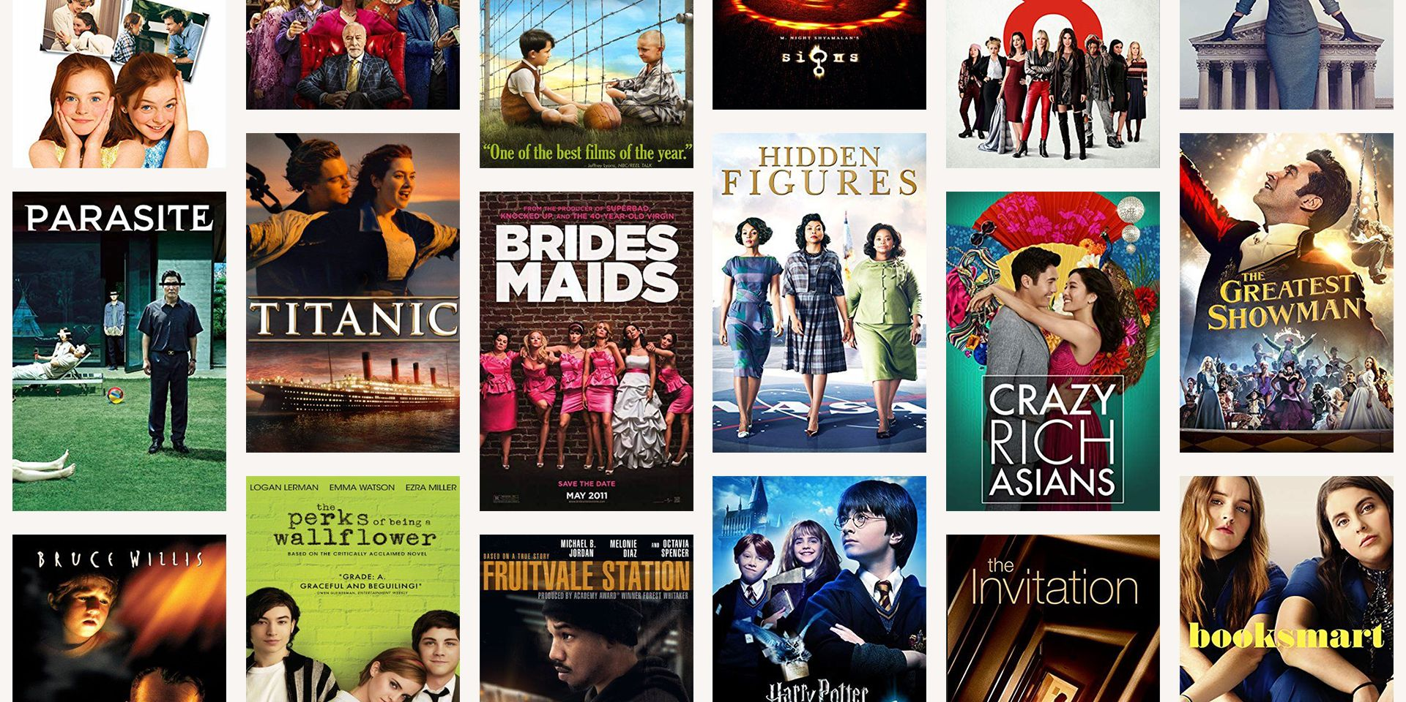

Project : Cinema library

1. collection of films, cartoons and TV series of different genres
2. Registration and creation of a user account
3. recommendations for the user: by recent film releases, future projects
4. evaluation of the film and the opportunity to leave a review

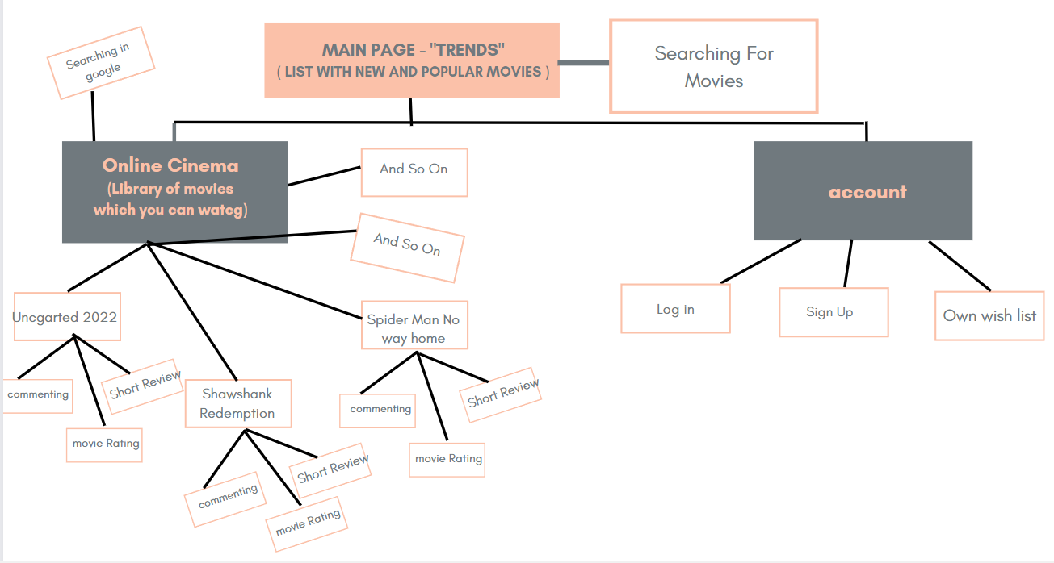

In “Trends” in my website you can see new and popular movies. There is also an opportunity to search by the name of the movie. This is all I did using the API from “Kinopoisk”.

In “Online Cinema ” page you will have the opportunity to watch the movie online. This will be implemented through the database and the server.

